Name : Manan Madan

Roll Number : 2018UIC3087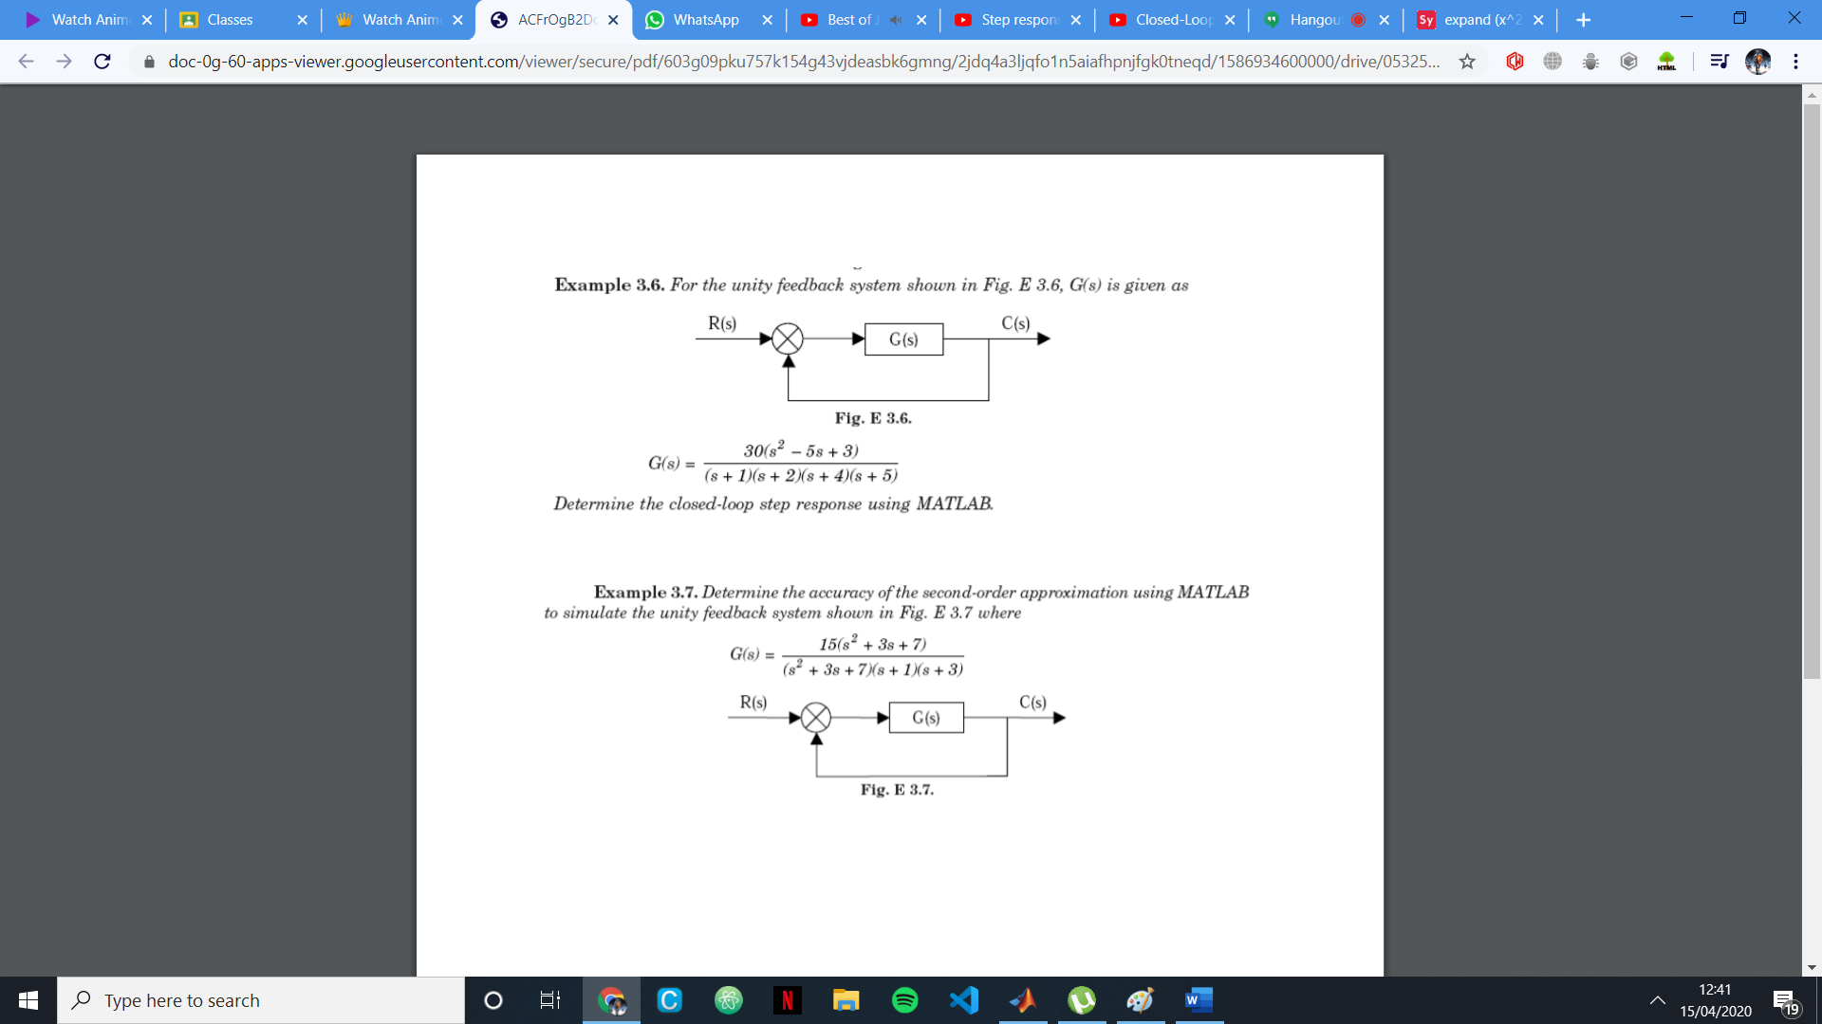

# The Forward Amplification:

G = 30 s^2 - 150 s + 90

---------------------------------

s^4 + 12 s^3 + 49 s^2 + 78 s + 40

Continuous-time transfer function.

# The closed loop transfer function:

H = 30 s^2 - 150 s + 90

----------------------------------

s^4 + 12 s^3 + 79 s^2 - 72 s + 130

Continuous-time transfer function.

# Step Response:

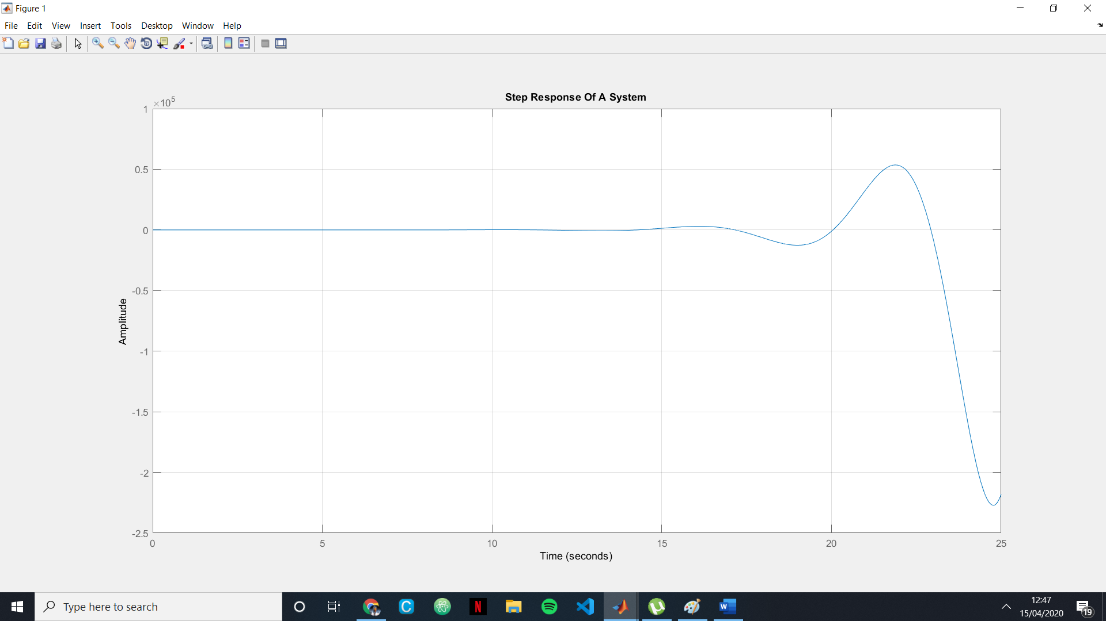

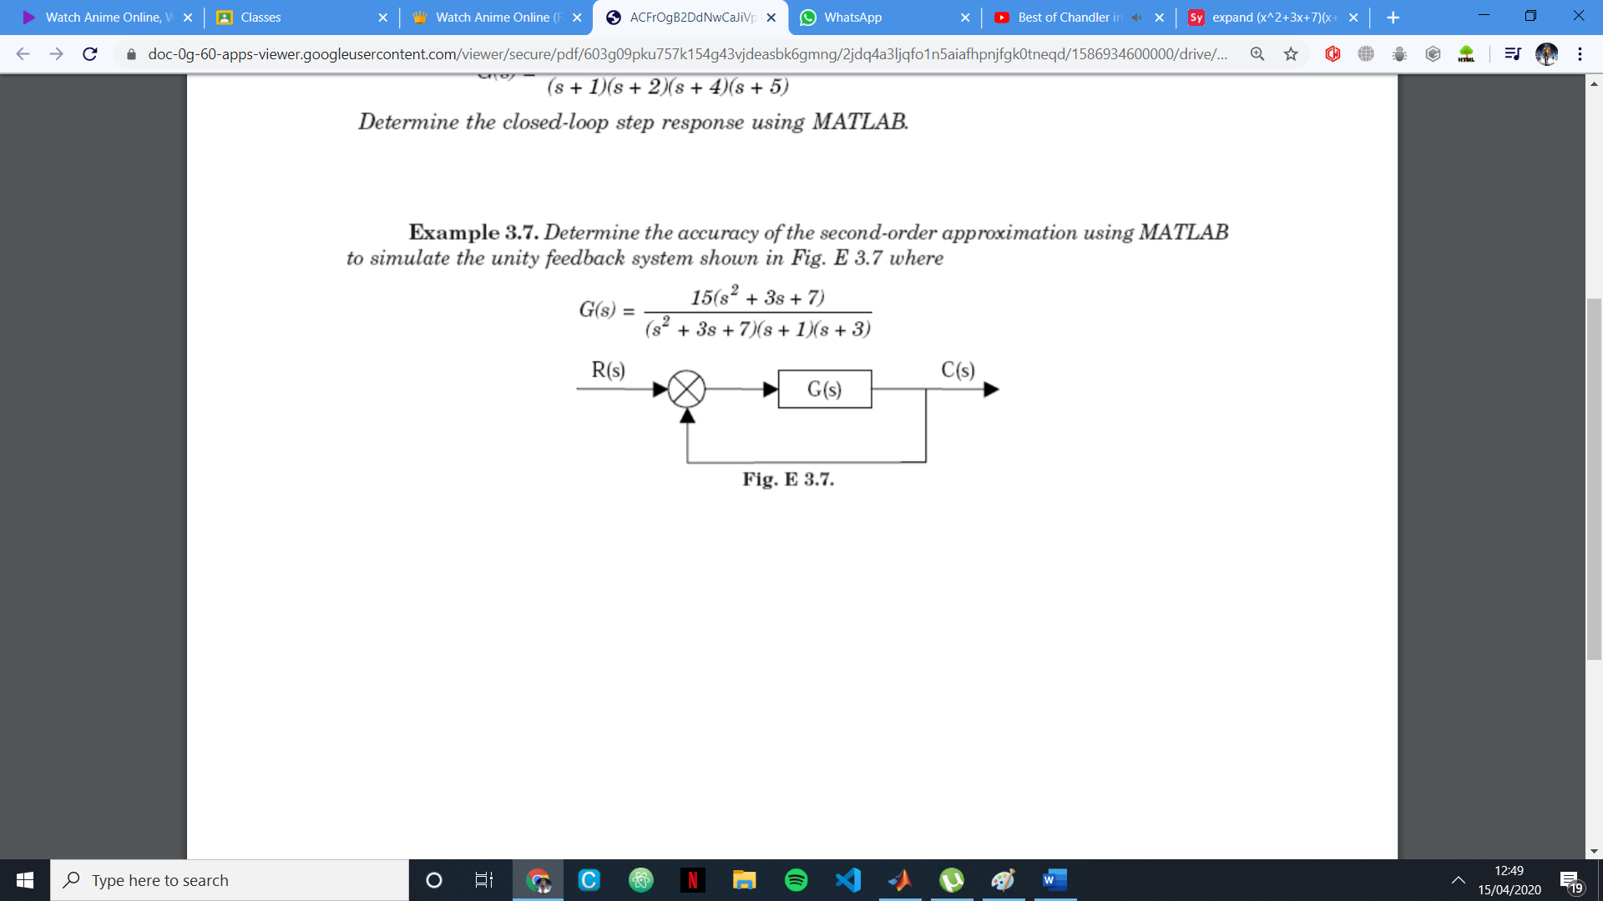

# The Forward Amplification:

G = 15 s^2 + 45 s + 105

--------------------------------

s^4 + 7 s^3 + 22 s^2 + 37 s + 21

Continuous-time transfer function.

# The closed loop transfer function:

H = 15 s^2 + 45 s + 105

---------------------------------

s^4 + 7 s^3 + 37 s^2 + 82 s + 126

Continuous-time transfer function.

# Step Response:

